Welcome to mCheque Print

2 tips for a simpler way to print setup

# Open printer setup menu

By click on print setup menu user can open print setup dialog which is shown like this.

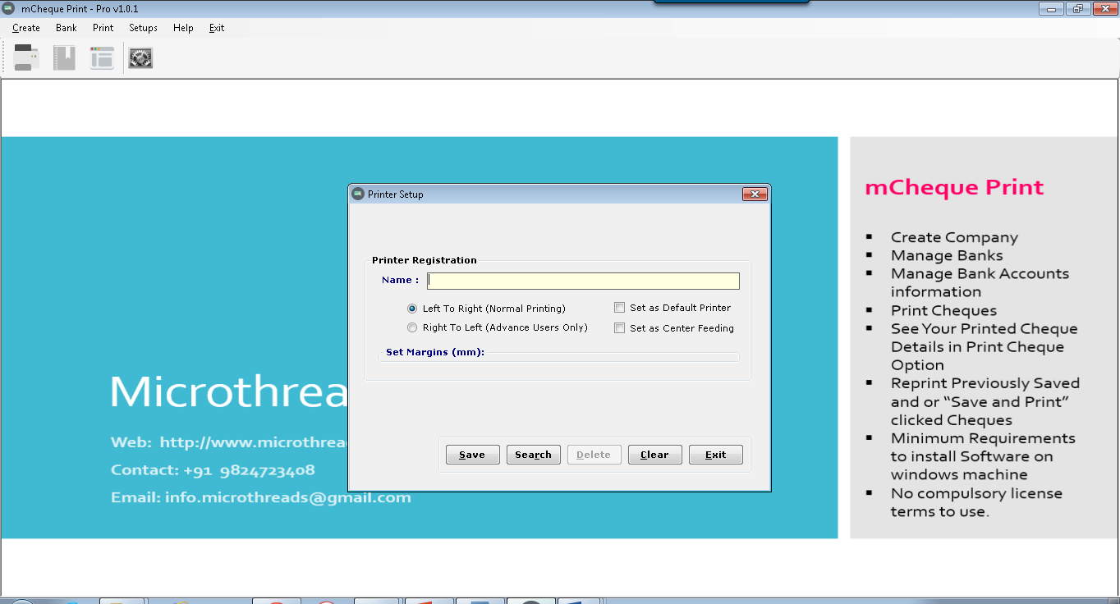

In this dialog user can setup printer name and its print position.

Steps:

1. Enter printer name.
2. Enter printing type.
   1. If you want to print left to right as per cheque writing. Select Left To Right.
   2. If you want to print Right to left as per cheque writing. Select Right to Left.
3. Set Margins (All parameters are in millimeter).
   1. LEFT means if you want to move margin from left to right of cheque.
   2. TOP means if you want to move margin from top to bottom of cheque.
   3. TOP means if you want to move margin from top to bottom of cheque.
   4. BOTTOM means if you want to move margin from bottom to top of cheque.
4. Check “Set as Default Printer” if you want to print regularly from this printer.
5. Check “Set as Center Feeding” if your printer if print from center.

# Other printer setup

Some Printer (Like Multi Function Inkjet Printers) cannot direct support small cheque size. So you need to enter cheque size in it.

1. For Windows XP Users

* Click start >> Control Panel
* Then go to “Printers and Faxes”
* Then Select your printer
* Then “ALT+F” or open FILE Menu
* Then Select “Server Properties”

Then You can Find Below Mentioned Window.

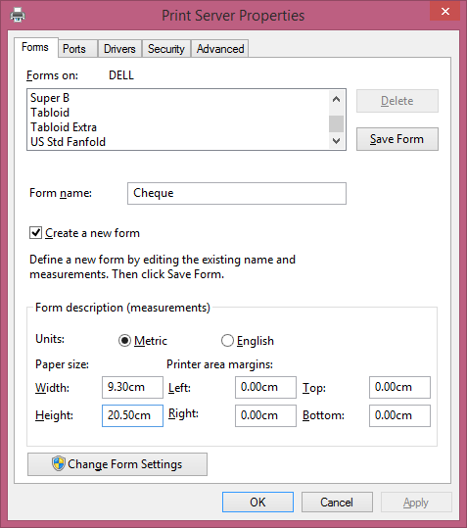

* Then Check on “Create a new Form”
* Enter Form Name as per you remember , Like “Cheque”
* In Units Check Metric
* In Paper size Width :- 9.30 Cm and Height 20.50 Cm
* Then Click on OK Button
* Then again select printer and right click and select properties then re enter cheque size details again if required.

1. For Windows 7/8/10 Users

* Click on Start >> Device and Printer
* Select your printer using Single Click
* Then Below Address bar you can find option “Print Server Properties”

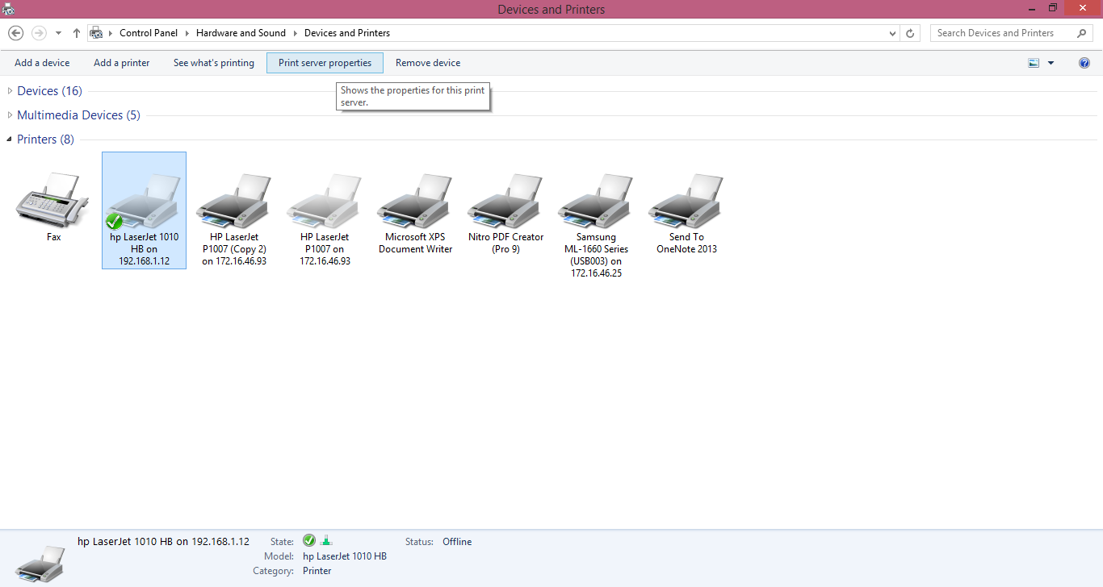

Then You can Find Below Mentioned Window



* Then Check on “Create a new Form”
* Enter Form Name as per you remember , Like “Cheque”
* In Units Check Metric
* In Paper size Width :- 9.30 Cm and Height 20.50 Cm
* Then Click on OK Button
* Then again select printer and right click and select properties then re enter cheque size details again if required.